For the problems in the first part, no submission is required.

1] Solve this quiz found at the end of Lesson 4:

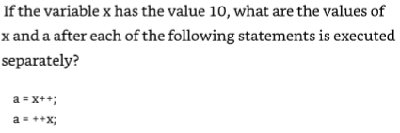

First solve it with pencil and paper: Answer for x++ (post-increment): a is 10, x is 11.

Answer for ++x (pre-increment): a is 11, x is 11.

Now write a C program with two integer variables a and x. Do not forget to declare and initialize both variables! After doing all the work required, the program will print both a and x.

Important: You will need two versions of the program, one with pre-increment, and one with post-increment. Submit screenshots of the code and output for both versions!

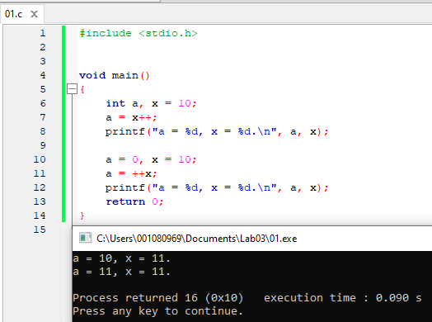

2] Solve this quiz found at the end of Lesson 4:



First, solve it with pencil and paper: Answer: 19

Now write a C program with an integer variable that is assigned the expression. The program will print the variable at the end, so we can make sure we got the same result.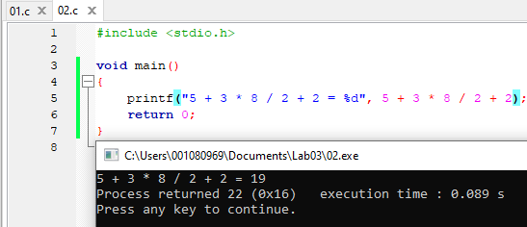

3] Write a program to calculate the remainders and quotients of the integers 1000, 2000, and 3000 when divided by 7. The integers should be implemented as one variable that is initialized with 1000 and then reused for 2000 and 3000.

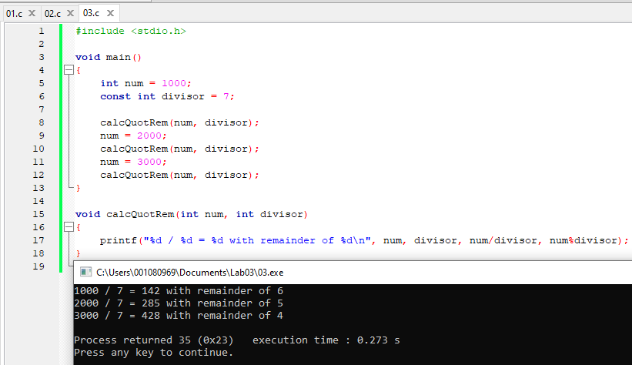

4] Application of nested **if**s:

The integer variable **score** contains the score a student got on an exam (0-100).

* Ask the user to enter the score, then scan it in the program.
* Write a decision statement (if) to print the corresponding grade (F-A)
  + We may assume that the scores are integers from 0 to 100.
  + 90 to 100 (inclusive) is A, 80 to 99 is a B, etc. 0 to 59 is F.
* Test the program with scores for each grade

Software engineering hint: Test the various grades in either increasing or decreasing order in order to keep the logic as simple as possible!  
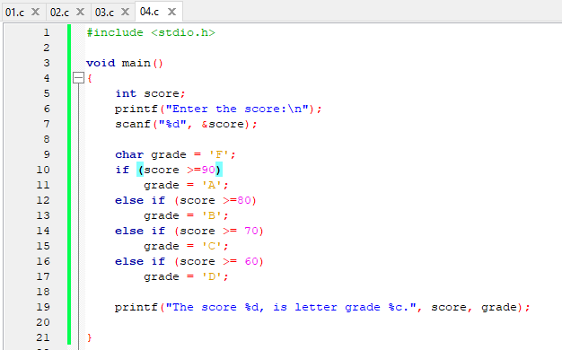

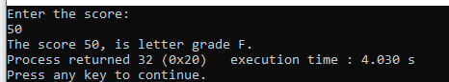

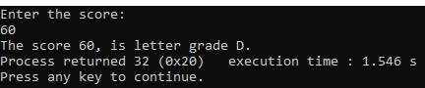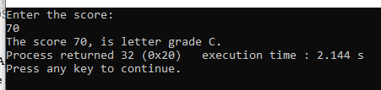

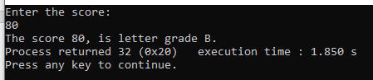

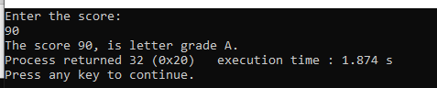

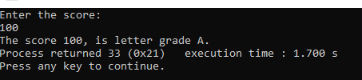

**To submit for lab report**

--- All problems in this section require screenshots of source code and output! ---

1] Write a program that does the following:

* Declares a floating point variable (use single precision)
* Asks the user to enter the value
* Reads the value from the keyboard
* Displays the value on the screen
* Displays either “Negative”, “Zero”, or “Positive!”, depending on the actual value. (Hint: You will need two if statements!)

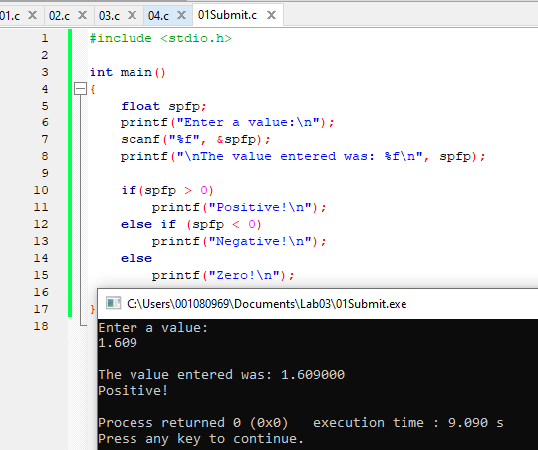

2] Solve Exercise 8 at the end of Lesson 4 (p.90) first with pencil and paper:

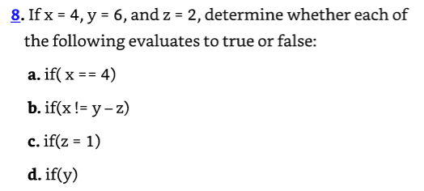

a. true b. false

c. true d. true

[No need to submit the p-and-p answers for the report.]

Then write a program where you declare and initialize all the variables, and use the if statements above to print *true* or *false*.

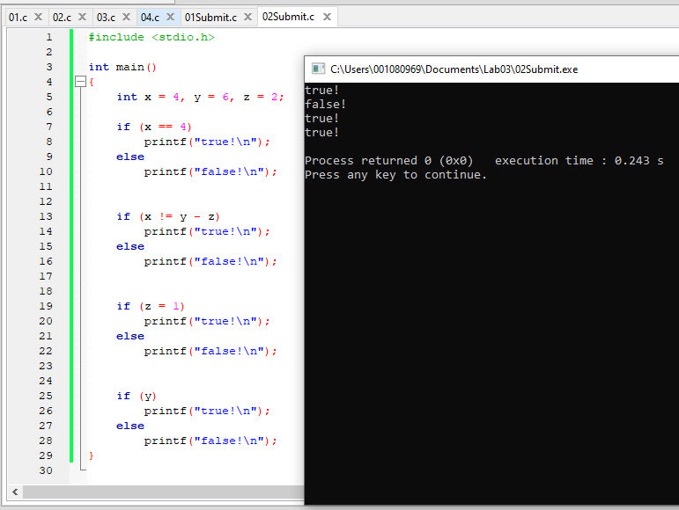

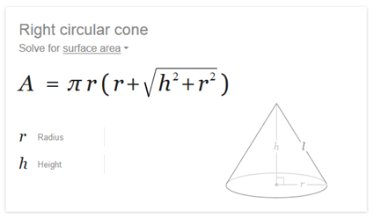3] Write a program to calculate the total area of a cone according to the formula shown.

The user should enter the values of the height and the radius as floats from the keyboard.

Hints:

* Include math.h, and define PI as a preprocessor constant.
* The “square root” function sqrt() is declared in math.h. You can also use pow() with a fractional power of 0.5.
* Use parentheses to enforce the correct order of operations!

Test with r = 2 and h = 1.5. The result should be close to 28.27.

